

E-DONATION APPLICATION

User Training Manual (UTM)

Version 1.0 (Final)

03/09/2019

REFERENCE PAGE

DOCUMENT AUTHORISATION

 | Name | Signature | Date
Prepared By | Pavitra |  | 02/09/2019
Received By | Athirah Fauzi
Reviewed By | Izzati Husna
Approved By | Pn. Mawarwiduri binti Ab Halik

DOCUMENT HISTORY

Document Version | Date | Author | Description of Amendments

Table of Contents

e-Donation Application
1 Login 1
2 Sign up 3
3 Member Main Menu 5
4 Update Information 8
5 Add New Donation Request 10
6 Donation Request List 12
7 Update Donation Approval Status 14
8 Delete Donation Request 16
9 Donation Request Report…...……………………………………………………18
10 Applicant Main Menu………………..…………………………………………..20
11 Update Information 22
12 Add New Donation Request 24
13 View Donation Approval Status 26

E-DONATION APPLICATION

Login
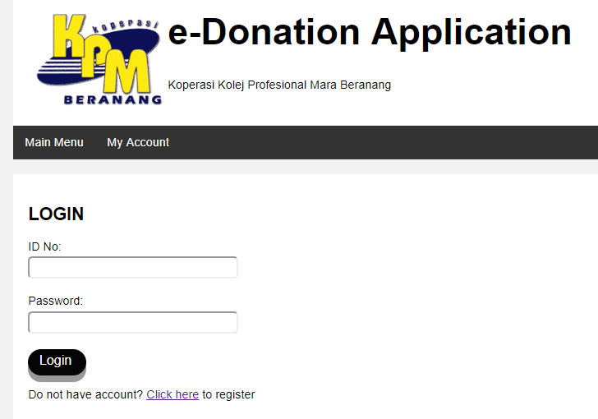
- This Login form is to authorized the applicant or member of Koperasi KPM Beranang to enter to e-Donation Application

Features;
- Functions provided: Main Menu, My Account, Login and Click here

Getting Started;
- This form will be firstly displayed when user enter the link of this e-Donation Application.

Main Menu
- Click on the Main Menu button.
  - The Login form will be displayed.

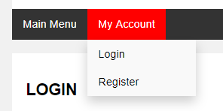
My Account

- Click on the My Account button.
- The dropdown menu will be displayed.
    - Click on Login button and the Login form will be displayed
    - Click on the Register button and the Sign up form will be displayed.

Correct ID No and Password
- Users enter the correct ID No and password into the text field provided.
- Click Login button.
- If user is an applicant, the Applicant Main Menu page will be displayed. But if user is a member of Koperasi KPM Beranang, the Member Main Menu page will be displayed.

Incorrect ID No and Password
- Enter incorrect ID No and password into the text field provided.
- User click Login button.
- Error message page “Unsuccessful! Please try again.” displayed
- Then, the error message page will redirect to the Login form.
- Users must re-enter the correct username and password into the text field provided and click Login button.

Click Here
- Click on the Click Here button.
  - The Signup form will be displayed.

Sign up Form
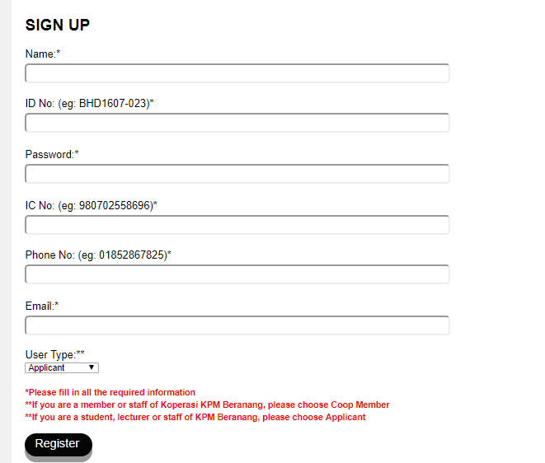
- This Sign Up form is to register and add new applicant or new member of Koperasi KPM Beranang.

Features;
- Functions provided: Main Menu, My Account and Register

Getting Started;
- This form will be displayed when users click on Click Here button in Login form.

Main Menu
- Click on the Main Menu button.
- The Login form will be displayed.

My Account

- Click on the My Account button.
- The dropdown menu will be displayed.
    - Click on Login button and the Login form will be displayed
    - Click on the Register button and the Sign up form will be displayed.

Register
- User must fill in Name, ID No, Password, IC No, Phone No, Email and Select User Type.
- Click Register button.
- The user will successfully register and all the record will be successfully saved in the database.
3 Member Main Menu
- This Main Menu page is for Member of Koperasi KPM Beranang.
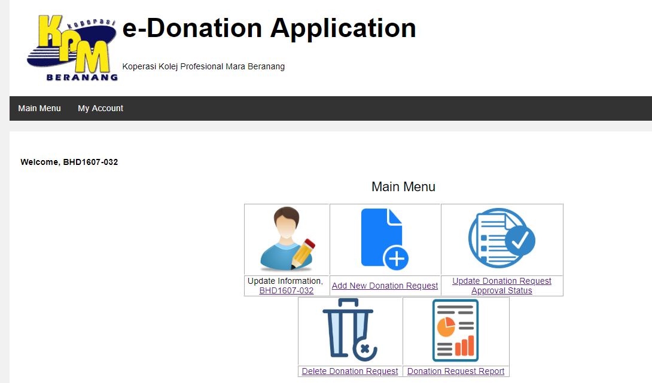

Features;
- Functions provided: Main Menu, My Account, Update Information, Add New Donation Request, Donation Request Approval, Delete Donation Request and Donation Request Report

Getting Started;
- This page will be displayed when member of Koperasi KPM Beranang enter correct ID No and Password.

Main Menu
- Click on Main Menu button.
- Member Main Menu page will be displayed

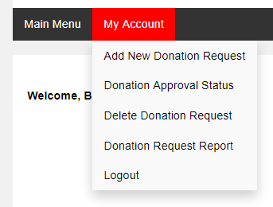
My Account

- Click on My Account button.
- The dropdown menu will be displayed.
  - Click on Add New Donation Request button and the Add New Donation Request form will be displayed.
  - Click on Donation Approval Status button and the Donation Request List page will be displayed.
  - Click on Delete Donation Request button and the Delete Donation Request page will be displayed.
  - Click on Donation Request Report button and the Donation Request Report page will be displayed.
  - Click on Logout button and the account will be logout, the Login page will be displayed.

Update Information
- Click on the ID No button.
- Update Information page will be displayed.

Add New Donation Request
- Click on the Add New Donation Request button.
- Add New Donation Request form will be displayed.

Update Donation Request Approval Status
- Click on the Update Donation Request Approval Status button.
- Donation Request List page will be displayed.

Delete Donation Request
- Click on the Delete Donation Request button.
- Delete Donation Request page will be displayed.

Donation Request Report
- Click on the Donation Request Report button.
- Donation Request Report page will be displayed

4 Update Information
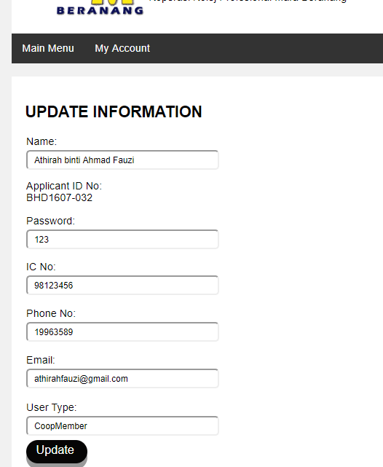
- This form allows member of Koperasi KPM Beranang to update their information.

Features;
- Function provided: Main Menu, My Account and Update.

Getting Started;
- This page will be displayed when member of Koperasi KPM Beranang click on the ID No button at Member Main Menu.

Main Menu
- Click on Main Menu button.
- Member Main Menu page will be displayed
My Account

- Click on My Account button.
- The dropdown menu will be displayed.
  - Click on Add New Donation Request button and the Add New Donation Request form will be displayed.
  - Click on Donation Approval Status button and the Donation Request List page will be displayed.
  - Click on Delete Donation Request button and the Delete Donation Request page will be displayed.
  - Click on Donation Request Report button and the Donation Request Report page will be displayed.
  - Click on Logout button and the account will be logout, the Login page will be displayed.

Update Information
- User can change and update the information Name, Password, IC No, Phone No, Email and User Type by entering new information in text field provided.
- Click Update button.
- The information will be successfully updated in the database.

5. Add New Donation Request
- This form allows users to add new donation request.
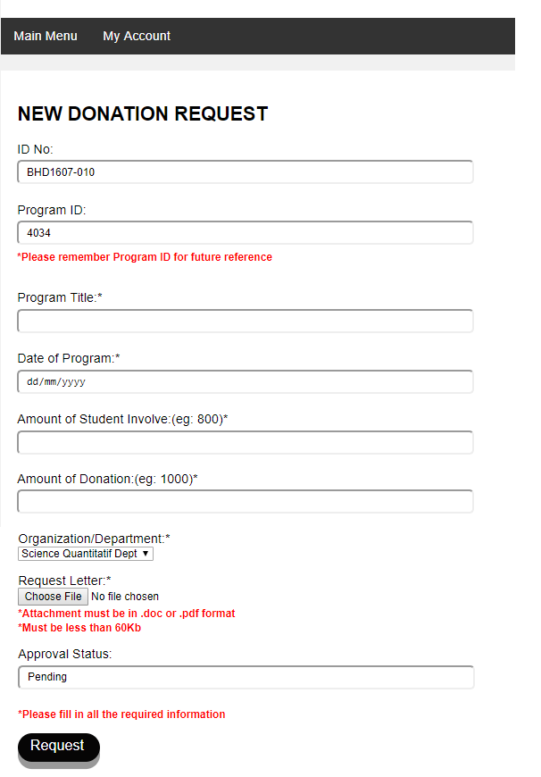

Features;
- Function provided: Main Menu, My Account and Request.

Getting Started;
- This page will be displayed when Member of Koperasi KPM Beranang click on the Add New Donation Request button at Member Main Menu.

Main Menu
- Click on Main Menu button.
- Member Main Menu page will be displayed

My Account

- Click on My Account button.
- The dropdown menu will be displayed.
  - Click on Add New Donation Request button and the Add New Donation Request form will be displayed.
  - Click on Donation Approval Status button and the Donation Request List page will be displayed.
  - Click on Delete Donation Request button and the Delete Donation Request page will be displayed.
  - Click on Donation Request Report button and the Donation Request Report page will be displayed.
  - Click on Logout button and the account will be logout, the Login page will be displayed.
Request
- User must fill in Program Title, Date of Program, Amount of Student Involve, Amount of Donation, select Organization/Department and attach Request Letter.
- Click Request button.
- The donation will be successfully requested and all the record will be successfully saved in the database.

6 Donation Request List
- This form allow user to select donation request to be updated according to the selected Organization/Department.
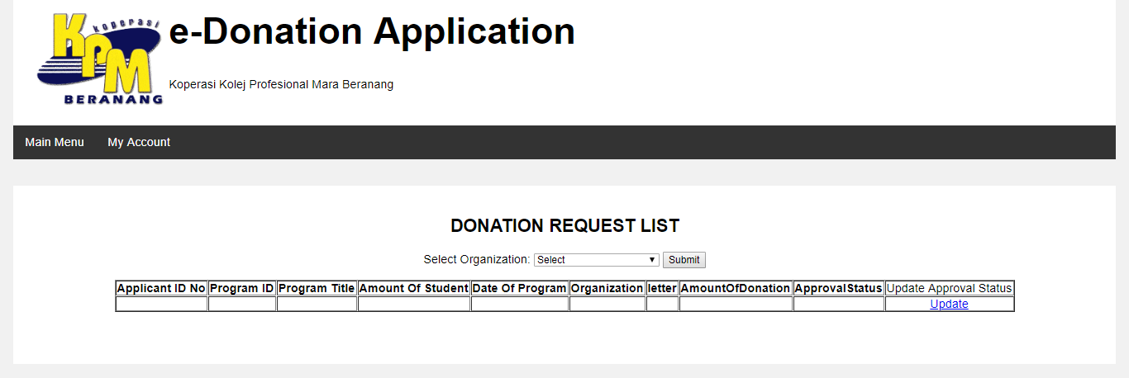

Features;
- Function provided: Main Menu, My Account, Submit and Update

Getting Started;
1. This page will be displayed when member of Koperasi KPM Beranang click on the Update Donation Request Approval Status button at Member Main Menu.

Main Menu
- Click on Main Menu button.
- Member Main Menu page will be displayed

My Account

- Click on My Account button.
- The dropdown menu will be displayed.
  - Click on Add New Donation Request button and the Add New Donation Request form will be displayed.
  - Click on Donation Approval Status button and the Donation Request List page will be displayed.
  - Click on Delete Donation Request button and the Delete Donation Request page will be displayed.
  - Click on Donation Request Report button and the Donation Request Report page will be displayed.
  - Click on Logout button and the account will be logout, the Login page will be displayed.

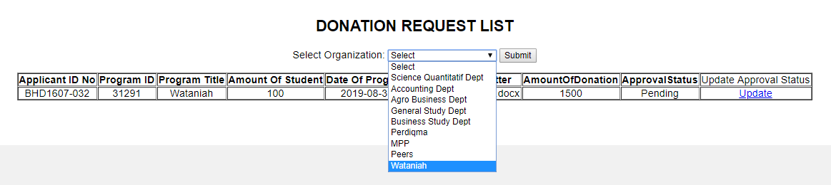
Submit

- User must select Organization/Department from the selection box provided.
- User click on the Submit button.
- The list of donation request according to the selected Organization/Department will be displayed.

Update
- User click on Update button for each of the donation request.
- The Update Donation Approval Status page will be displayed.

7 Update Donation Approval Status
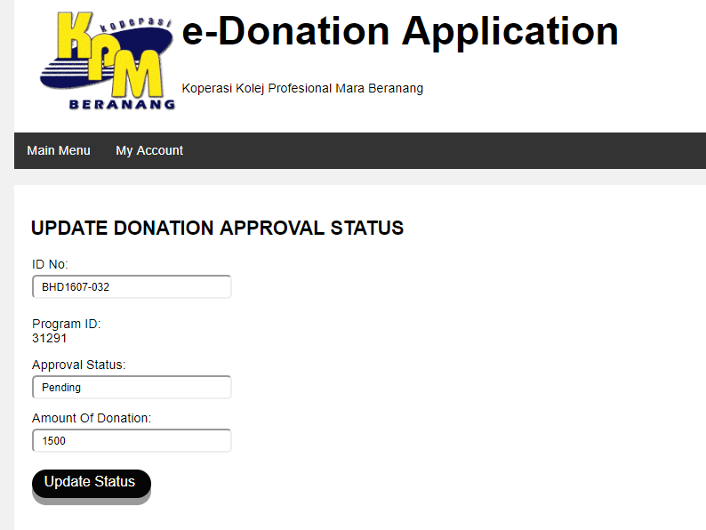
- This form allows user to update the donation request approval status.

Features;
- Function provided: Main Menu, My Account and Update.

Getting Started;
- This page will be displayed when member of Koperasi KPM Beranang click on the Update button at Donation Request List page.

Main Menu
- Click on Main Menu button.
- Member Main Menu page will be displayed

My Account

- Click on My Account button.
- The dropdown menu will be displayed.
  - Click on Add New Donation Request button and the Add New Donation Request form will be displayed.
  - Click on Donation Approval Status button and the Donation Request List page will be displayed.
  - Click on Delete Donation Request button and the Delete Donation Request page will be displayed.
  - Click on Donation Request Report button and the Donation Request Report page will be displayed.
  - Click on Logout button and the account will be logout, the Login page will be displayed.

Update Information
- User can change and update the status of the donation and amount of the donation by entering new information in text field provided.
- Click Update button.
- The information will be successfully updated in the database.

8 Delete Donation Request
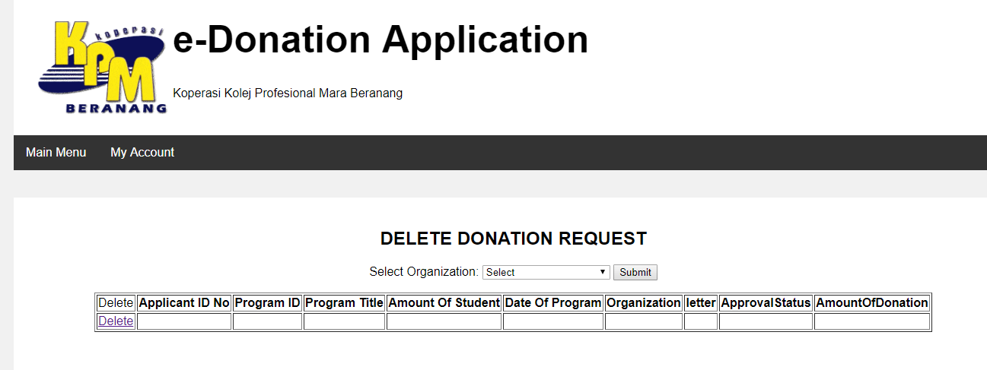
- This page allows users to delete the donation request based the selected Organization/Department.

Features;
- Function provided: Main Menu, My Account, Submit and Delete.

Getting Started;
- This page will be displayed when member of Koperasi KPM Beranang click on the Delete Donation Request button at Member Main Menu.

Main Menu
- Click on Main Menu button.
- Member Main Menu page will be displayed

My Account

- Click on My Account button.
- The dropdown menu will be displayed.
  - Click on Add New Donation Request button and the Add New Donation Request form will be displayed.
  - Click on Donation Approval Status button and the Donation Request List page will be displayed.
  - Click on Delete Donation Request button and the Delete Donation Request page will be displayed.
  - Click on Donation Request Report button and the Donation Request Report page will be displayed.
  - Click on Logout button and the account will be logout, the Login page will be displayed.

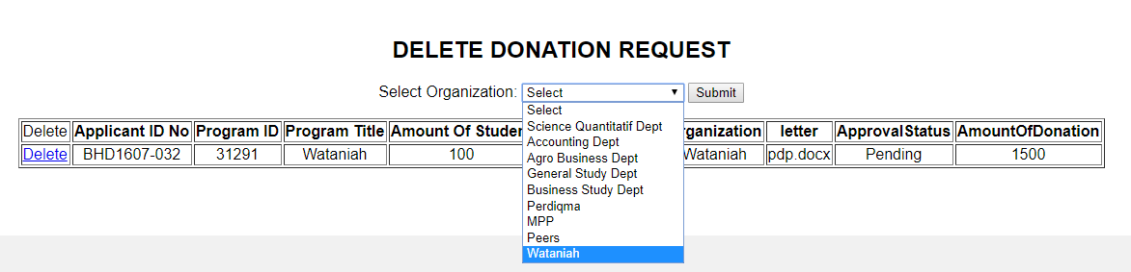
Submit

- User must select Organization/Department from the selection box provided.
- User click on the Submit button.
- The list of donation request according to the selected Organization/Department will be displayed.

Delete
- User click on Delete button for each of the donation request.
- The selected donation request and its details will be deleted from the list.

9 Donation Request Report
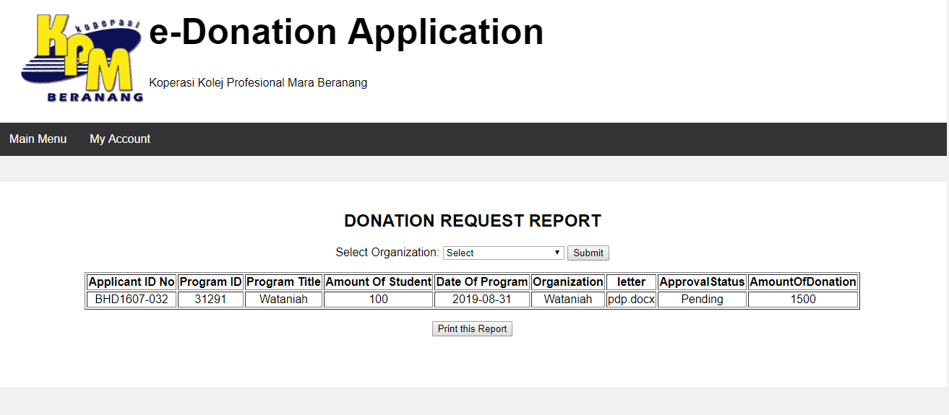
- This form allows users to view and print donation request report according to selected Organization/Department.

Features;
- Function provided: Main Menu, My Account, Submit and Print this Report.

Getting Started;
- This page will be displayed when member of Koperasi KPM Beranang click on the Donation Request Report button at Member Main Menu.

Main Menu
- Click on Main Menu button.
- Member Main Menu page will be displayed

My Account

- Click on My Account button.
- The dropdown menu will be displayed.
  - Click on Add New Donation Request button and the Add New Donation Request form will be displayed.
  - Click on Donation Approval Status button and the Donation Request List page will be displayed.
  - Click on Delete Donation Request button and the Delete Donation Request page will be displayed.
  - Click on Donation Request Report button and the Donation Request Report page will be displayed.
  - Click on Logout button and the account will be logout, the Login page will be displayed.

Submit

- User must select Organization/Department from the selection box provided.
- User click on the Submit button.
- The report of donation request according to the selected Organization/Department will be displayed.

Print this Report
- User click on Print this Report.
- The browser print preview will be displayed.

10 Applicant Main Menu
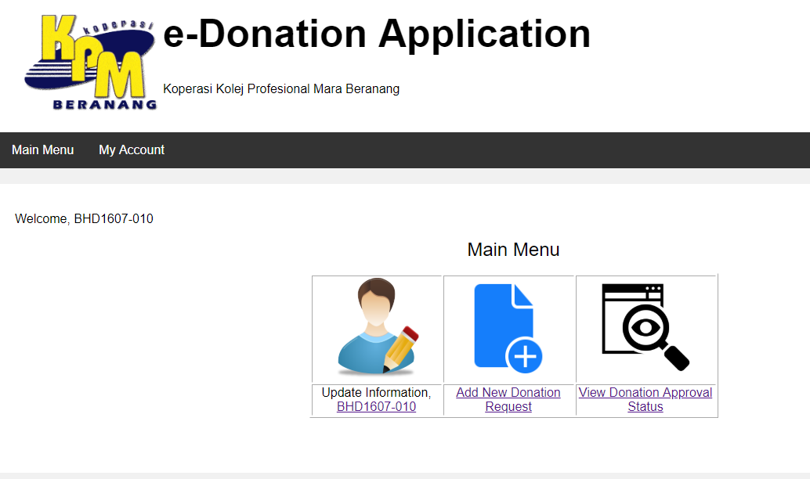
- This main menu page is for applicant of donation.

Features;
- Functions provided: Main Menu, My Account, Update Information, Add New Donation Request and View Donation Approval Status.

Getting Started;
- This page will be displayed when Applicant enter correct ID No and Password at Login page.

Main Menu
- Click on Main Menu button.
- Member Main Menu page will be displayed

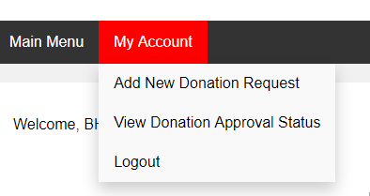
My Account

- Click on My Account button.
- The dropdown menu will be displayed.
  - Click on Add New Donation Request button and the Add New Donation Request form will be displayed.
  - Click on View Donation Approval Status button and the Donation Approval Status page will be displayed.
  - Click on Logout button and the account will be logout, the Login page will be displayed.

Update Information
- Click on the ID No button.
- Update Information page will be displayed.

Add New Donation Request
- Click on the Add New Donation Request button.
- Add New Donation Request form will be displayed.

View Donation Approval Status
- Click on the View Donation Approval Status button.
- The Donation Approval Status page will be displayed.
.

11 Update Information
- This form allows Applicant to update their information.
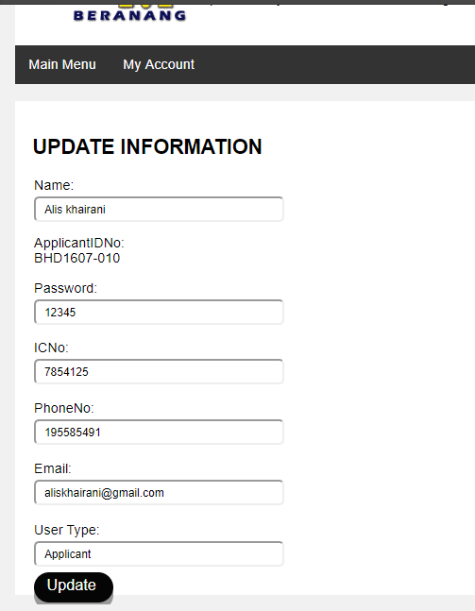
Features;
- Function provided: Main Menu, My Account and Update.

Getting Started;
- This page will be displayed when applicant click on the ID No button at Applicant Main Menu.

Main Menu
- Click on Main Menu button.
- Member Main Menu page will be displayed
My Account

- Click on My Account button.
- The dropdown menu will be displayed.
  - Click on Add New Donation Request button and the Add New Donation Request form will be displayed.
  - Click on View Donation Approval Status button and the Donation Approval Status page will be displayed.
  - Click on Logout button and the account will be logout, the Login page will be displayed.

Update Information
- User can change and update the information Name, Password, IC No, Phone No, Email and User Type by entering new information in text field provided.
- Click Update button.
- The information will be successfully updated in the database.

12 Add New Donation Request
- This form allows users to add new donation request.

Features;
- Function provided: Main Menu, My Account and Request.

Getting Started;
- This page will be displayed when applicant click on the Add New Donation Request button at Applicant Main Menu.

Main Menu
- Click on Main Menu button.
- Member Main Menu page will be displayed

My Account

- Click on My Account button.
- The dropdown menu will be displayed.
  - Click on Add New Donation Request button and the Add New Donation Request form will be displayed.
  - Click on View Donation Approval Status button and the Donation Approval Status page will be displayed.
  - Click on Logout button and the account will be logout, the Login page will be displayed.

Request
- User must fill in Program Title, Date of Program, Amount of Student Involve, Amount of Donation, select Organization/Department and attach Request Letter.
- Click Request button.
- The donation will be successfully requested and all the record will be successfully saved in the database.

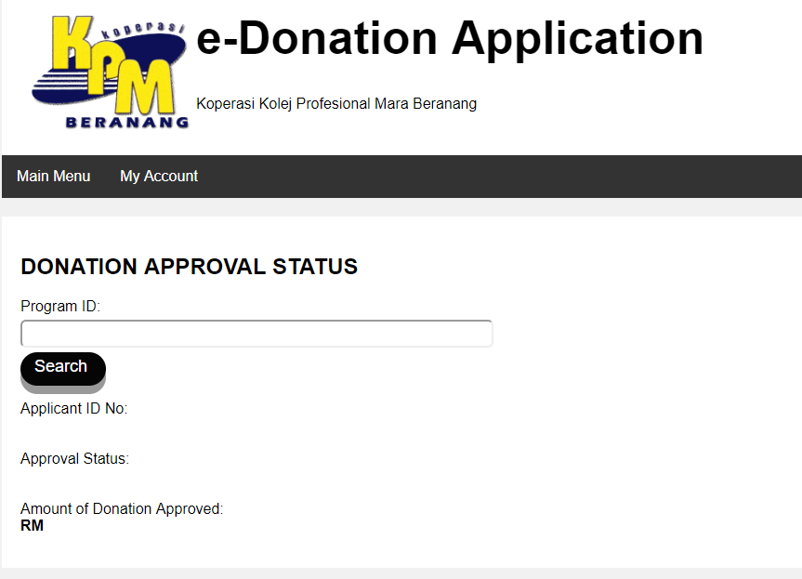
13 View Donation Approval Status

Features;
- Function provided: Main Menu, My Account and Search.

Getting Started;
- This page will be displayed when applicant click on the View Donation Approval Status button at Applicant Main Menu.

Main Menu
- Click on Main Menu button.
- Member Main Menu page will be displayed

My Account

- Click on My Account button.
- The dropdown menu will be displayed.
  - Click on Add New Donation Request button and the Add New Donation Request form will be displayed.
  - Click on View Donation Approval Status button and the Donation Approval Status page will be displayed.
  - Click on Logout button and the account will be logout, the Login page will be displayed.

Search
- User enter correct Program ID.
- Click on Search button.
- The donation information and status for the entered Program ID will be displayed.

